**Fop Lab Home Task 9**

**Name:** Hafiz Mufassir Amjad

**CMS ID:** 456049

**Section:** B

**(NOTE:** Codes are attached in main.cpp file.**)**

**HOME TASK**

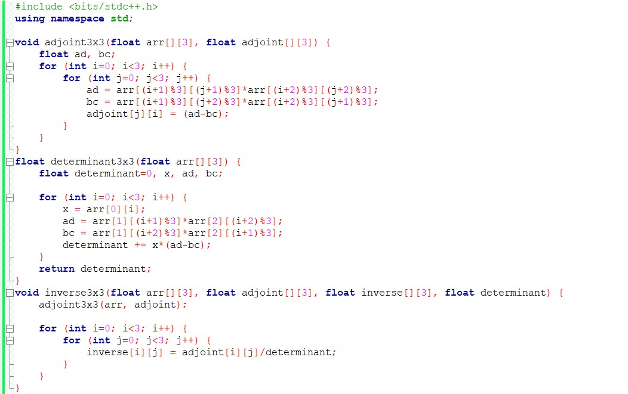

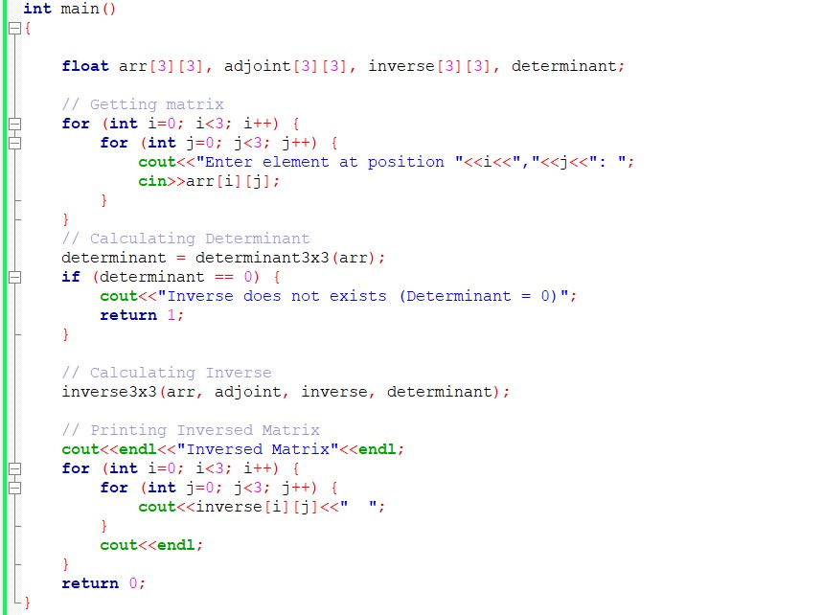

**Output 1**

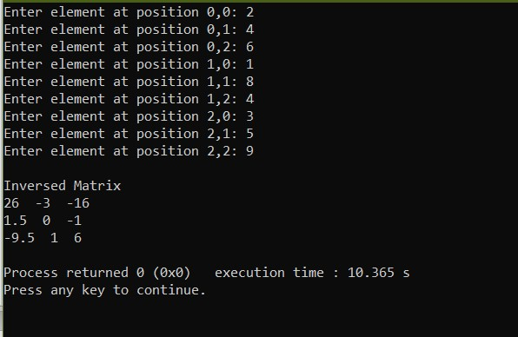

**Output 2**

